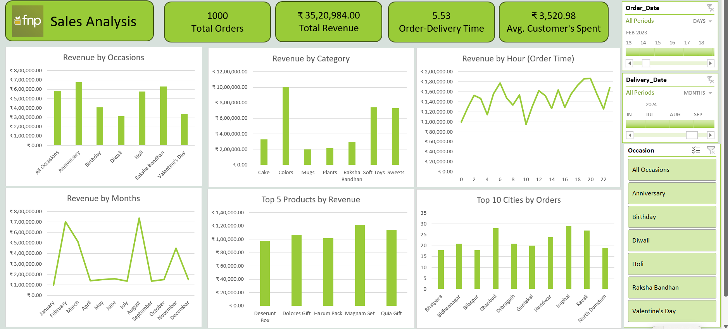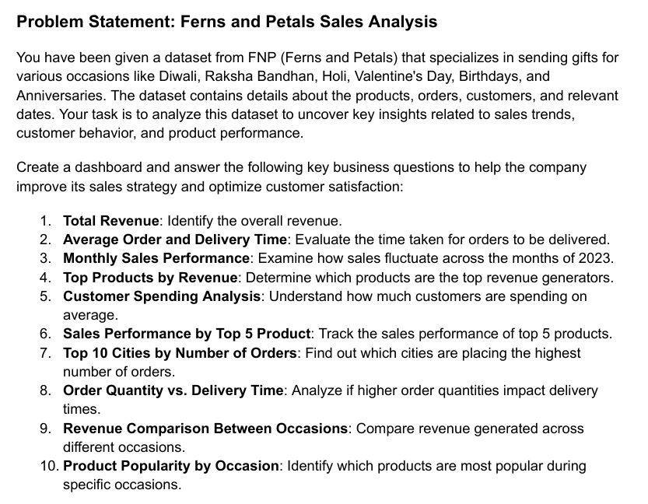

**Executive Summary for Sales Analysis Dashboard**

**Project Overview:** The Sales Analysis Dashboard was developed to provide actionable insights into the sales performance of an e-commerce business. The dashboard leverages key metrics and visualizations to assist decision-makers in identifying trends, improving revenue streams, and optimizing operational efficiency.

**Key Insights:**

1. **Total Orders and Revenue:**
   * **Total Orders:** 1000
   * **Total Revenue:** ₹35,20,984
   * Average revenue per customer: ₹3,520.98
2. **Delivery Performance:**
   * Average order-delivery time: 5.53 days
3. **Revenue by Category:**
   * Top revenue-generating categories include **Cakes**, **Soft Toys**, and **Mugs**.
4. **Occasion-Based Revenue:**
   * Major contributors are **Anniversary** and **Birthday** sales, highlighting opportunities for targeted marketing.
5. **Time-Based Revenue Analysis:**
   * Peak revenue generation occurs between **10 AM and 2 PM**, with a noticeable dip after 6 PM.
6. **Top Performing Products:**
   * Key revenue drivers are **Execution-Item Pack**, **Expedia Gift**, and **Fuggi Set**.
7. **Monthly Revenue Trends:**
   * Highest revenue observed in **January**, indicating seasonality in sales.
   * Consistent dips during mid-year months like **June and July**.
8. **City-wise Sales Performance:**
   * Top cities by orders include **Kavali**, **Machilipatnam**, and **Kaylan-Dombivli**.
   * Insights can help with regional promotional strategies.

**Tools and Technologies Used:**

* **Power BI** for data visualization.
* **SQL** for data extraction and transformation.
* Advanced **Excel** for preliminary data cleaning and analysis.

**Recommendations:**

1. **Marketing Strategies:**
   * Focus on top-performing occasions (Anniversary, Birthday) and regions (Kavali, Machilipatnam).
   * Utilize peak time slots for promotional offers (10 AM - 2 PM).
2. **Operational Improvements:**
   * Aim to reduce the average delivery time to enhance customer satisfaction.
   * Address low-performing months with targeted campaigns.
3. **Product Insights:**
   * Expand inventory of top-performing products and analyze customer feedback for low-performing ones.

**🎉 Excited to Share My Latest Data Visualization Project! 📊**

**I recently worked on a Sales Analysis Dashboard that provides in-depth insights into business performance. This dashboard was built using Power BI and highlights key metrics such as:**

**✅ Total Revenue: ₹35,20,984  
✅ Top Performing Products & Categories  
✅ Revenue Trends by Occasions, Months, and Hours  
✅ City-Wise Sales Performance  
✅ Order Delivery Time Optimization**

**Some key takeaways:**

* **Peak revenue is driven by occasions like Anniversary and Birthday sales.**
* **Delivery time averages 5.53 days, highlighting room for operational improvement.**
* **Major sales activity occurs between 10 AM to 2 PM, creating opportunities for time-sensitive promotions.**

**This project enhanced my skills in Power BI, SQL, and data storytelling. It was an exciting opportunity to transform raw data into meaningful insights for strategic decision-making! 🚀**

**💡 Let me know your thoughts or suggestions on how I can improve this further!**

**#DataAnalytics #PowerBI #DataVisualization #SalesAnalysis #BusinessInsights #DataStorytelling**

**I am excited to share my latest project, a Sales Analysis Dashboard built using Power BI.**

**This dashboard provides key insights into business performance, including:**

* **Total Revenue: ₹35,20,984**
* **Revenue trends by occasions, months, and hours**
* **Top-performing products and cities**
* **Average order delivery time: 5.53 days**

**The project helped me strengthen my skills in Power BI, SQL, and data storytelling while deriving actionable insights to support strategic decision-making.**

**I look forward to hearing your feedback.**

**#DataAnalytics #PowerBI #SalesAnalysis #DataVisualization #BusinessInsights**